A1-20171-SQL-DBS301

DUE DATE: Nothing will be accepted after this date. It will get a zero

**Due BEFORE MIDNIGHT on the FRIDAY of WEEK 6**

**PLAGIARISM**   
When you submit an assignment, you are saying that the submission is your own work and as such you wish to be given credit for the work.

Occasionally, especially when working on a design problem or writing programs (but never on exams or tests!), it may be necessary to ask someone for a small amount of help. You are permitted to do so, provided you meet the following two conditions.

1 You acknowledge the help on the work you hand in, including explaining the work or portion of the work done or assisted by another person.

2 You understand the work that you hand in, so that you could explain the reasoning behind the parts of the work done for you or assisted by another.

Any other assistance by another person constitutes a violation called plagiarism and will be treated as such.

When 2 or more of you work together as a group, only one assignment should be submitted with all the members’ names on it at the time of submission. If two submissions exist, that are essentially the same, then both submissions cannot possibly make the claim that the work is "solely their own". This is a serious matter and is considered plagiarism. It is recorded in accordance with College policy and may result in a penalty such as expulsion from the College. Please do not put yourself in this position. Plagiarism is very easy to detect.

**Anyone not in this list cannot be added to the group later**

Name(s) Student ID(s) Section A, B or C

Alejandro Mesa 038515151 Section B

______________________________________________________________________________

______________________________________________________________________________

______________________________________________________________________________

The above acknowledges you understand.

INSTRUCTION:

1 Rename this WORD file A1-xxxxx where xxxxx is replaced with your email account name, not the whole email. If you are in a group pick one of them.

2 When finished email this back to me and CC everyone in your group as proof it was sent.

3 The following tables are used for this assignment. You will be given a script to load.

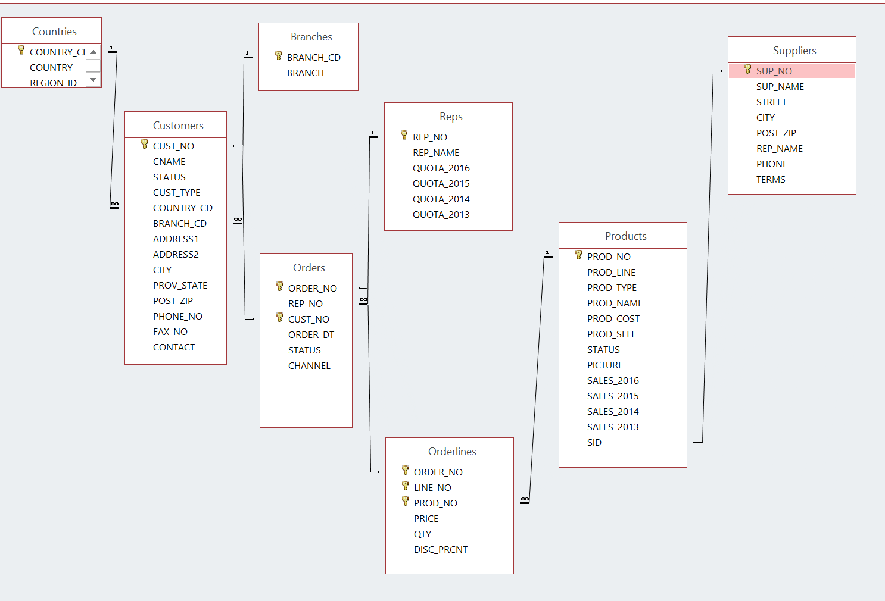

NOTE:

If any output goes on for more than 100 lines, only cut and paste the first 100 or so. I don’t want to get this word document too big.

1. Display the customer number, customer name and country code for all the customers that are in SPAIN. The country code for Spain is SPA. Please note that you are given SPA, or spa or SpA to use and not Spain.

**SQL:**



SELECT CUST_NO,CNAME,COUNTRY_CD



FROM CUSTOMERS



WHERE upper(COUNTRY_CD) = upper('SPA');

**OUTPUT:**

CUST_NO CNAME COUN

---------- ------------------------------ ----

1095 Supremax Montagna 1 SPA

1096 Supremax Montagna 2 SPA

1097 Supremax Montagna 3 SPA

1098 GO Outlet Madrid SPA

1019 Supremax Montagna 5 SPA

1035 Ultra Sports 1 SPA

2. How many orders have the product number 40302?

**SQL:**



SELECT COUNT(ORDER_NO)

FROM ORDERLINES

WHERE PROD_NO = 40302;



**OUTPUT:**



COUNT(ORDER_NO)



---------------------------------------

22

3. List the customer number, customer name and order number for customers that ordered product 40302. Put result in customer number order.

**SQL:**

SELECT c.CUST_NO,

c.CNAME,

o.ORDER_NO

FROM CUSTOMERS c

JOIN ORDERS o

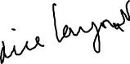

ON c.CUST_NO = o.CUST_NO

JOIN ORDERLINES l

ON o.ORDER_NO = l.ORDER_NO



WHERE l.PROD_NO = 40302

ORDER BY c.CUST_NO;



**OUTPUT:**

CUST_NO CNAME ORDER_NO

---------- ------------------------------ ----------

1001 GO Outlet Montreal 67

1005 GO Outlet Boston 153

1019 Supremax Montagna 5 78

1036 Ultra Sports 2 11

1039 Vacation Central 1 65

1041 Vacation Central 3 33

1045 Mountain Madness 3 16

1051 Sportwaren G.m.b.H. 1 139

1062 123 Fitness PTE Ltd 38

1066 Wilderness Wonderment Ltd 164



1069 Andes Camping Supplies 3 157



1071 Lookout Below Ltd 37

1078 Act'N'Up Fitness 4 44

1083 Over the Top Cycles 1 77

1095 Supremax Montagna 1 205

1102 Pro Form Supplies 4 28

1121 GO Outlet Manchester 15

1127 Fresh Air Co 1 135

1129 Fresh Air Co 3 101

1130 Fresh Air Lte 4 120

1139 Fredies Sport Whse 1 194

1148 Juan's Sports 2 2

4 Display the customer number for Ultra Sports 5.

**SQL:**

SELECT CUST_NO



FROM CUSTOMERS



WHERE upper(CNAME) = upper('Ultra Sports 5');



**OUTPUT:**

CUST_NO

----------

1002

5 Display all orders for United Kingdom. The word entered is United Kingdom and not UK. Show only cities that start with L.

Display the customer number, customer name, order number, product name, the total dollars for that line. Give that last column the name of TOTAL.

Put the output into customer number order from highest to lowest and display only order numbers less than 75

**SQL:**

SELECT c.CUST_NO,

c.CNAME,

o.ORDER_NO,

p.PROD_NAME,



l.QTY * l.PRICE * (1 - l.DISC_PERC/100) AS TOTAL

FROM CUSTOMERS c

JOIN COUNTRIES n

ON c.COUNTRY_CD = n.COUNTRY_ID

JOIN ORDERS o

ON c.CUST_NO = o.CUST_NO

JOIN ORDERLINES l

ON o.ORDER_NO = l.ORDER_NO

JOIN PRODUCTS p



ON l.PROD_NO = p.PROD_NO



WHERE upper(COUNTRY_NAME) = upper('United Kingdom')

AND upper(c.CITY) LIKE 'L%'

AND o.ORDER_NO < 75

ORDER BY c.CUST_NO DESC;

**OUTPUT:**

CUST_NO CNAME ORDER_NO PROD_NAME TOTAL

---------- ------------------------------ ---------- ------------------------------ ----------

1120 GO Outlet London 61 Pro-Lite Water Filter 141.9

1120 GO Outlet London 49 Day Tripper 11.2

1120 GO Outlet London 61 GO Wristband 334.08

1120 GO Outlet London 61 MoonGlow 1425.45

1120 GO Outlet London 61 GO Camp Kettle 1395.03

1120 GO Outlet London 61 Star Lite 5441.7

1120 GO Outlet London 29 Pocket U.V. Alerter 552.42

1120 GO Outlet London 29 RiverKind Detergent 1769.88

1120 GO Outlet London 29 GO Wristband 499.2

1120 GO Outlet London 29 GO Cookset 1300.32

1120 GO Outlet London 29 MoonGlow 1960.8

1120 GO Outlet London 49 RiverKind Shampoo 424.08

1120 GO Outlet London 49 Pocket Water Filter 3364.2

1120 GO Outlet London 49 GO Headband 288

1120 GO Outlet London 49 GO Cookset 1194.48

1120 GO Outlet London 49 Pack n' Hike 214.84

1120 GO Outlet London 61 Pocket Water Filter 8202.6

6 Display a count of how many different country codes there are

**SQL:**

SELECT COUNT(DISTINCT COUNTRY_CD)

FROM CUSTOMERS;

**OUTPUT:**

COUNT(DISTINCTCOUNTRY_CD)

---------------------------------------

14

7 Find the total dollar value for all orders from London. Each row will show customer name, order number and total dollars for the order. Sort by order number

**SQL:**

SELECT c.CNAME,

o.ORDER_NO,

SUM(l.QTY * l.PRICE * (1 - l.DISC_PERC/100)) AS TOTAL

FROM CUSTOMERS c

JOIN ORDERS o

ON c.CUST_NO = o.CUST_NO

JOIN ORDERLINES l

ON o.ORDER_NO = l.ORDER_NO

WHERE upper(c.CITY) = upper('London')

GROUP BY c.CNAME,

o.ORDER_NO

ORDER BY o.ORDER_NO;

**OUTPUT:**

CNAME ORDER_NO TOTAL

------------------------------ ---------- ----------

GO Outlet London 29 6082.62

GO Outlet London 49 5496.8

GO Outlet London 61 16940.76

GO Outlet London 107 25317.28

Trees to Seas Ltd 122 4241.9

Trees to Seas Ltd 170 4895.53

**Going back to the same tables you have used for labs that came from demobld10g**

8 Display the (a) employee number, (b) full employee name, (c) job and (d) hire date.

**Bold text indicate changes done to correspond with email that was sent on February 19.**

- Limit the display to all employees hired in **May, June, July, August or December** of any year.

- The most recently hired employees are displayed first.

- Exclude people hired in **1992 to 1996.**

- Full name should be in the form 🡪 *Lastname, Firstname --* with an alias called *Full Name.*

- Hire date should point to the last day in May, June, July, August or December of that year (NOT to the exact hire date)

- The format is in the form of *May 31st of* ***1997*** –better if there is no big gap between month and 31st

- The hire date column should be called *Start Date*.

**NOTE: Do NOT use a LIKE operator.**

You should display ONE row per output line by limiting the width of the *Full Name* to 25 characters.

**SQL:**

SELECT EMPLOYEE_ID,

SUBSTR(LAST_NAME || ', ' || FIRST_NAME,1,25) AS "Full Name",

JOB_ID,

to_char(last_day(HIRE_DATE), 'FMMonth ddth "of" YYYY') AS "Start Date"

FROM EMPLOYEES

WHERE TRIM(to_char(HIRE_DATE, 'MONTH')) IN (upper('May'), upper('June'), upper('July'), upper('August'), upper('December'))

AND to_char(HIRE_DATE, 'YYYY') NOT BETWEEN 1992 AND 1996

ORDER BY HIRE_DATE DESC;

**OUTPUT:**

EMPLOYEE_ID Full Name JOB_ID Start Date

----------- ------------------------- ---------- ----------------------------

178 Grant, Kimberely SA_REP May 31st of 1999

144 Vargas, Peter ST_CLERK July 31st of 1998

202 Fay, Pat MK_REP August 31st of 1997

104 Ernst, Bruce IT_PROG May 31st of 1991

100 King, Steven AD_PRES June 30th of 1987

9 List the employee number, full name, job and the modified salary for all employees

- whose monthly earning (without the increase) is outside the range $6,000 – $11,000

- and who are employed as a Vice Presidents or Managers (President is not counted here).

- You should use **Wild Card** characters for this.

- the modified salary for a VP will be 30% higher

- and managers a 20% salary increase.

- Sort the output by the top salaries (before this increase).

Heading will be: 🡪 *Employees with Increased Pay*

**The output lines should look like this sample line:**

Employee 101 named Neena Kochhar with Job ID of AD_VP will have a new salary of $22100

**SQL:**

SELECT 'Employee '

|| EMPLOYEE_ID

|| ' named '

|| FIRST_NAME

|| ' '

|| LAST_NAME

|| ' with JOB_ID of '

|| JOB_ID

|| ' will have a new salary of $'

|| CASE

WHEN upper(JOB_ID) LIKE upper('%VP')

THEN SALARY * 1.30

WHEN upper(JOB_ID) LIKE upper('%MAN')

THEN SALARY * 1.20

ELSE SALARY

END AS "Employees with Increased Pay"

FROM EMPLOYEES

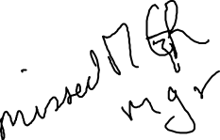

WHERE SALARY NOT BETWEEN 6000 AND 11000

AND upper(JOB_ID) LIKE upper('%VP')

OR upper(JOB_ID) LIKE upper('%MAN')

ORDER BY SALARY DESC;

**OUTPUT:**

Employees with Increased Pay

-----------------------------------------------------------------------------------------

Employee 101 named Neena Kochhar with JOB_ID of AD_VP will have a new salary of $22100

Employee 102 named Lex De Haan with JOB_ID of AD_VP will have a new salary of $22100

Employee 201 named Michael Hartstein with JOB_ID of MK_MAN will have a new salary of $15600

Employee 149 named Eleni Zlotkey with JOB_ID of SA_MAN will have a new salary of $12600

Employee 124 named Kevin Mourgos with JOB_ID of ST_MAN will have a new salary of $6960

10 Display last_name, job id and salary for all employees who earn more than all lowest paid employees per **[**department that are in locations outside the US**]**.

Exclude President and Vice Presidents from this query.

Sort the output by job id ascending.

If a JOIN is needed you must use a “newer” method (USING/JOIN)

**After consulting about it with you in a lab class I interpreted that there is no country restriction on the displayed employees, only on the departments used to look for lowest paid employees’ salaries.**

**To restrict the query to also exclude the employees actually working in US, one would add the following clause to the main query’s WHERE statement:**

**AND upper(l.COUNTRY_ID) != upper('US')**

**SQL:**

SELECT e.LAST_NAME,

e.JOB_ID,

e.SALARY

FROM EMPLOYEES e

JOIN DEPARTMENTs d

ON e.DEPARTMENT_ID = d.DEPARTMENT_ID

JOIN LOCATIONS l

ON d.LOCATION_ID = l.LOCATION_ID

WHERE upper(e.JOB_ID) NOT LIKE upper('%VP')

AND upper(e.JOB_ID) NOT LIKE upper('%PRES')

AND SALARY > ALL (SELECT MIN(SALARY)

FROM EMPLOYEES e

JOIN DEPARTMENTs d

ON e.DEPARTMENT_ID = d.DEPARTMENT_ID

JOIN LOCATIONS l

ON d.LOCATION_ID = l.LOCATION_ID

WHERE upper(l.COUNTRY_ID) != upper('US')

GROUP BY e.DEPARTMENT_ID)

ORDER BY e.JOB_ID;

**OUTPUT:**

LAST_NAME JOB_ID SALARY

------------------------- ---------- ----------

Higgins AC_MGR 12000

Hunold IT_PROG 9000

Hartstein MK_MAN 13000

Zlotkey SA_MAN 10500

Abel SA_REP 11000

11 Who are the employees (show last_name, salary and job) who work either in IT , ACCOUNTING or MARKETING department and earn more than the worst paid person in the SHIPPING department.

Sort the output by the last name alphabetically.

**You need to use ONLY the Subquery method (NO joins allowed).**

**SQL:**

SELECT LAST_NAME,

SALARY,

JOB_ID

FROM EMPLOYEES

WHERE DEPARTMENT_ID IN (SELECT DEPARTMENT_ID

FROM DEPARTMENTS

WHERE upper(DEPARTMENT_NAME) IN (upper('IT'), upper('Accounting'),

upper('Marketing')))

AND SALARY > (SELECT MIN(SALARY)

FROM EMPLOYEES

WHERE DEPARTMENT_ID = ( SELECT DEPARTMENT_ID

FROM DEPARTMENTS

WHERE upper(DEPARTMENT_NAME) = upper('Shipping')))

ORDER BY LAST_NAME;

**OUTPUT:**

LAST_NAME SALARY JOB_ID

------------------------- ---------- ----------

Ernst 6000 IT_PROG

Fay 6000 MK_REP

Gietz 8300 AC_ACCOUNT

Hartstein 13000 MK_MAN

Higgins 12000 AC_MGR

Hunold 9000 IT_PROG

Lorentz 4200 IT_PROG

12 Display Department_id, Job_id and the Lowest salary for this combination but only if that Lowest Pay falls in the range $6000 - $18000.

Exclude people who

(a) work as some kind of *Representative* job from this query and

(b) departments IT and SALES

Sort the output according to the Department_id and then by Job_id.

You MUST NOT use the Subquery method.

**SQL:**

SELECT e.DEPARTMENT_ID,

e.JOB_ID,

MIN(e.SALARY)

FROM EMPLOYEES e

JOIN DEPARTMENTS d

ON e.DEPARTMENT_ID = d.DEPARTMENT_ID



WHERE upper(e.JOB_ID) NOT LIKE upper('%REP')

AND upper(d.DEPARTMENT_NAME) NOT IN (upper('IT'), upper('Sales'))

GROUP BY e.DEPARTMENT_ID,

e.JOB_ID

HAVING MIN(e.SALARY) BETWEEN 6000 and 18000

ORDER BY e.DEPARTMENT_ID,

e.JOB_ID;



**OUTPUT:**

DEPARTMENT_ID JOB_ID MIN(E.SALARY)

------------- ---------- ---------------------------------------

20 MK_MAN 13000

90 AD_VP 17000

110 AC_ACCOUNT 8300

110 AC_MGR 12000